

Course Design Report

A Music Library Management and Community System Based on openGauss

College | Future Technology College
Major | Data Science and Big Data Technology
Student Name | LiXiaotong MoZebang YangRunyu ShengYiwen
Student ID | 2023
Instructor | Lin Yubei
Course Code | 084100881
Course Credit | 2.0
Start Date | 2025-02-10 to 2025-07-31

教  师  评  语 | 教师签名：  日期：
成
绩
评
定
备
注

Database Course Practical Training

Abstract:
This project designs and implements a music library management and community system based on openGauss, Python, and Streamlit. The system supports three roles: system administrator, music administrator, and listener. Role-based access control is used to separate user management, music resource management, and ordinary user interactions. At the database level, the system builds a normalized relational schema for users, artists, albums, songs, playlists, comments, forum posts, and post replies. Primary keys, foreign keys, constraints, indexes, a view, and a trigger are used to support data integrity, query efficiency, and consistency of derived statistics.
Functionally, the system provides song CRUD operations, cross-table fuzzy search, playlist and favorite management, comments, forum discussion, song recommendation, and ranking display. It also applies password hashing, parameterized SQL queries, connection pooling, pagination, transaction rollback, and reusable initialization logic to improve security and reliability. Through this project, we completed a functional database application and showed how database design decisions can support maintainability, performance, and real user workflows.
Keywords:
openGauss; music library management system; role-based access control; relational database design; fuzzy search; database trigger; Streamlit
Contents
1 Project Background 4
2 Design Justification (Design Philosophy) 5
3 Process Description 7
4 Results Analysis 14
5 Course Design Summary 16

Project Background

Problem Background
With the development of digital music platforms, users no longer only need to browse songs. They also expect to search music quickly, create personal playlists, comment on songs, recommend music to others and participate in community discussions.
From a database perspective, such a system involves many different entities and relationships. Songs are related to artists and albums. Users own playlists. Playlists contain multiple songs. Comments and posts connect users with music content. Based on this background, our project chooses a music library management and community system as the course design topic.
Compared with a simple management system, this topic contains richer data relationships and more typical database application scenarios. It is therefore suitable for practicing how a relational database supports both structured music management and user-centered community interaction.

Requirement Analysis
According to the course requirements, the system should be based on Huawei openGauss and should include different types of users, data management functions, query functions and permission management functions.
In our implementation, the original role model is adapted to the music scenario. The system contains three roles: sys_admin, music_admin and listener. The system administrator manages users and system content. The music administrator manages songs, artists, albums and community content. Ordinary listeners can search music, create playlists, collect songs, comment on songs and publish forum posts.
The system also covers the required data operations. It supports user management, music information addition, deletion, modification and query, playlist creation and deletion, song collection, comment management and forum content management. The query function is not limited to exact matching. Instead, it supports fuzzy search by song name, artist name and album name.

Project Objectives
The main objective of this project is to build a complete database application system that combines visible user functions with a reliable relational database structure. Specifically, the system aims to build a normalized music database on openGauss, support registration, login, and role-based permission control, implement music information management and cross-table fuzzy search, provide playlist, favorite, comment, forum, and ranking functions, and use constraints, indexes, views, and triggers to improve reliability and query efficiency.

Design Justification (Design Philosophy)

Overall Design Philosophy
The guiding principle of this project is database-driven application design. Instead of storing all information in a single large table, the system separates data according to stable business objects and connects them through relational constraints. This design reduces redundancy, improves maintainability, and allows the database to participate in enforcing application correctness.
During design, we treated business meaning as the basis for schema decisions. For example, playlists are modeled as independent objects rather than text fields of users, and forum posts are allowed to preserve their content even when the recommended song is removed. These decisions show that the database structure is not only technically normalized, but also aligned with actual user workflows.

System Architecture
The system adopts a four-layer architecture to separate concerns and maintain clarity.
Presentation Layer: Implemented using Streamlit, this layer manages user interaction, including login interfaces, music cards, forms, tabs, audio playback, and administrative panels.
Service Layer: Represented primarily by music_service.py, it performs input validation and returns standardized responses, ensuring that only valid data reaches the business logic.
Business Logic Layer: Implemented in music_manager.py and auth.py, this layer handles database operations, permission verification, and transaction commits, centralizing control of core functionality.
Database Layer: OpenGauss serves as the structured data store, enforcing constraints, maintaining indexes, managing views, and executing triggers. Uploaded media files such as audio tracks and avatars are stored in designated local folders, with database records maintaining their paths or URLs.
This layered design isolates responsibilities, allowing the interface to focus on interaction, the service layer to enforce input correctness, the business layer to execute operations reliably, and the database to guarantee data consistency and performance.

Conceptual Database Design
The conceptual database design contains nine core entities: Users, Artists, Albums, Songs, Playlists, Playlist_Songs, Comments, Posts, and Post_Comments. These entities cover three major parts of the system: user accounts, music resources, and community interaction.
The model uses direct entity relationships for one-to-many scenarios, such as users to playlists, artists to albums, and artists to songs. It also uses Playlist_Songs to represent the many-to-many relationship between playlists and songs. Comments, posts, and post comments connect users with music content and community discussions. This design separates music metadata, user-created collections, and user-generated content, providing a clear basis for later relational schema design.
Figure 1 is used to present the entity-relationship structure of the system. Its main purpose is to show the core entities, key attributes, relationship cardinalities, primary and foreign keys, and deletion rules in one unified diagram.
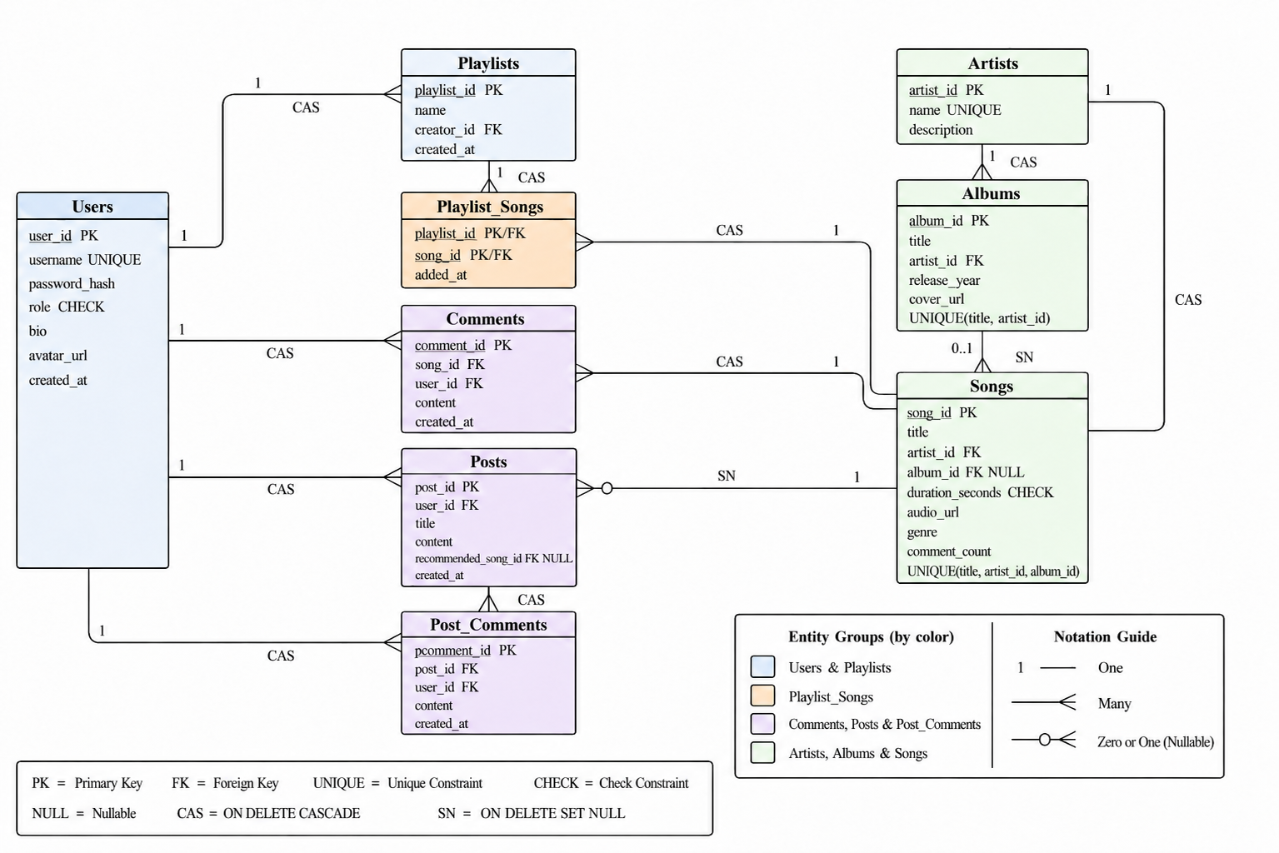
Figure 1 Entity-Relationship Diagram of the Music Library and Community System
As shown in Figure 1, the system is organized around four groups of entities. Users and playlists describe account-related and collection-related data; artists, albums, and songs describe music resources; comments, posts, and post comments describe community interaction; Playlist_Songs serves as the relationship table between playlists and songs. The diagram also marks key constraints such as primary keys, foreign keys, unique constraints, nullable fields, and check constraints. Relationship labels such as CAS and SN indicate the main deletion strategies, where CAS represents ON DELETE CASCADE and SN represents ON DELETE SET NULL. Therefore, the figure not only shows the conceptual data structure, but also reflects the integrity rules that guide the logical database design.

Logical Database Design
Based on the ER model, the system translates each entity into a relational table and uses primary keys, foreign keys, unique constraints, check constraints, and nullable fields to express the rules shown in the diagram. Primary keys ensure entity integrity, while foreign keys maintain relationships between users, music resources, playlists, comments, and posts. Unique constraints are used to prevent duplicate usernames, artists, albums, and songs in the same business context, while check constraints restrict invalid values such as unsupported roles or non-positive song duration.
Composite keys are used where a relationship itself needs to be uniquely identified. For example, Playlist_Songs(playlist_id, song_id) prevents the same song from being repeatedly added to the same playlist. Nullable foreign keys are used for optional relationships, such as the recommended song in a forum post or the album of a single track. This design keeps the schema concise while allowing the database to enforce important business rules directly.

Normalization Analysis
The database follows first, second, and third normal forms:
- 1NF: All fields store atomic values. Complex attributes such as multiple artists or song lists are represented in separate tables rather than concatenated fields.
- 2NF: Non-key attributes fully depend on the primary key. For Playlist_Songs, the added_at timestamp depends on both the playlist and song identifiers, ensuring accurate tracking.
- 3NF: Transitive dependencies are removed. Songs references artist_id and album_id rather than storing names directly, preventing data inconsistency if an artist or album changes.
Normalization reduces redundancy, prevents common anomalies, and simplifies future extensions, such as adding play history or song tags, without major schema changes.

Integrity Design
Data integrity is enforced through constraints and deletion rules. Strongly dependent records use ON DELETE CASCADE, while optional references use ON DELETE SET NULL to preserve meaningful content. The main deletion strategies are summarized in the table .
Relationship | Deletion Rule | Design Reason
Users → Playlists | ON DELETE CASCADE | Personal playlists lose their owner when the user is removed.
Users → Comments / Posts | ON DELETE CASCADE | User-generated personal content is removed with the account in this project.
Playlists → Playlist_Songs | ON DELETE CASCADE | Playlist-song records have no independent meaning without the playlist.
Songs → Playlist_Songs / Comments | ON DELETE CASCADE | Related playlist entries and comments depend on the song as their target.
Songs → Posts.recommended_song_id | ON DELETE SET NULL | A post may remain meaningful even if the recommended song is removed.
Artists → Albums / Songs | ON DELETE CASCADE | Deleting an artist removes the related music resources in the current system.
Albums → Songs | ON DELETE SET NULL | A song can still exist as a single track after album information is removed.

Query and Performance Design
Queries are designed for efficiency and practicality:
- Cross-table fuzzy search is implemented using ILIKE on song titles, artist names, and album titles, supporting partial keyword matches.
- Indexes are applied selectively to frequently searched or joined fields, and GIN trigram indexes are used when supported for more efficient pattern matching.
- Connection pooling via SimpleConnectionPool reduces overhead in repeated database access.
- Pagination is implemented using LIMIT and OFFSET to control data load and maintain responsiveness.
These considerations ensure that the system performs reliably under typical workloads, while remaining scalable as data volume increases.
Index Target | Query Scenario | Purpose
Songs(title) / GIN trigram index | Fuzzy search by song title | Improves keyword search efficiency.
Artists(name) / GIN trigram index | Fuzzy search by artist name | Supports cross-table search.
Albums(title) / GIN trigram index | Fuzzy search by album title | Supports album-based search.
Songs(artist_id) | Join Songs with Artists | Reduces join cost.
Songs(album_id) | Join Songs with Albums | Reduces join cost.
Playlist_Songs(song_id) | Favorite ranking and statistics | Speeds up grouping and aggregation.
Comments(song_id) | Comment lookup and ranking | Improves comment-related queries.

View and Trigger Design
The system uses a database view and a trigger to reduce repeated application logic and improve consistency. The view v_user_posts provides a unified query interface for forum display, so the application does not need to repeatedly construct complex joins. The trigger sync_song_comment_count maintains Songs.comment_count automatically when comments are inserted, deleted, or reassigned. These two designs show how the database can support application logic while keeping the Python code simpler and less error-prone.

Security Design
Security is addressed comprehensively:
- Passwords are hashed using PBKDF2-SHA256 rather than stored in plain text.
- Parameterized queries prevent SQL injection attacks.
- Role-based access control (RBAC) is enforced through decorators, centralizing permission logic and preventing unauthorized operations.
This approach ensures that security concerns are embedded within both the database and application layers, providing robust protection without compromising usability.

Process Description

Development Environment and Implementation Flow
The system is developed with openGauss, Python, Streamlit, and several supporting libraries. openGauss runs in a Docker container and provides the relational database service. Python is used to implement business logic and database access, while Streamlit is used to build the web interface. The database connection is implemented through psycopg2, password hashing is supported by Werkzeug, and audio-related processing is supported by libraries such as mutagen and pydub.
The implementation follows a bottom-up order. The database is prepared first, because all upper-layer functions depend on stable tables, constraints, indexes, views, and triggers. After the database structure is ready, the system connects user authentication, music management, search, playlist, forum, ranking, and frontend modules to the database. This order reduces dependency conflicts and makes the implementation easier to test step by step.
Figure 2 is used here to present the overall system architecture. Its main purpose is to show how the interface, service functions, business logic, and database cooperate with each other during system operation.
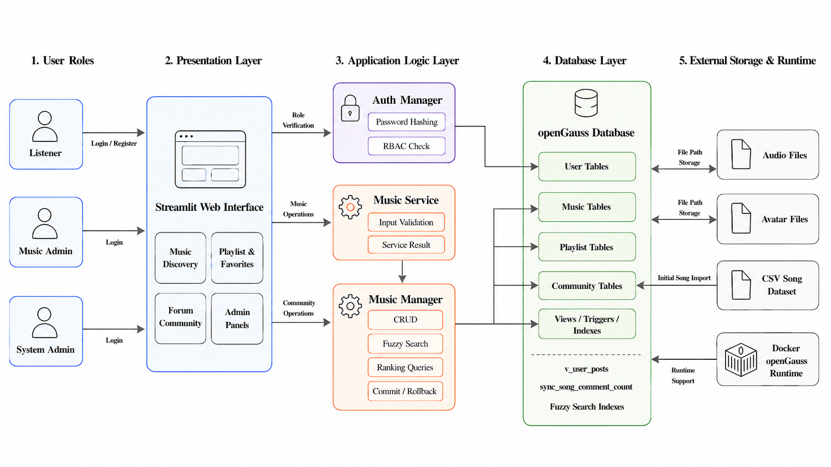
Figure 2 System Architecture Diagram
As shown in Figure 2, user requests start from the Streamlit interface and are then passed to the service and manager modules. The service layer validates input, while the manager layer performs permission checks, database operations, and transaction control. The database returns structured results to the backend, and the frontend displays them as pages, cards, forms, or messages. This process shows how the four-layer architecture is executed in actual system operation.

Database Initialization Process
The database initialization process is implemented in db_init.py. The script first connects to the default postgres database and checks whether the target business database exists. If reset mode is enabled, existing connections are terminated and the old database is recreated. This provides a clean starting point for development and testing.
After the target database is ready, the script opens a connection pool and creates database objects in dependency order. Basic tables are created first, followed by constraints, indexes, the forum view, and the comment-count trigger. Before stricter constraints are applied, the script repairs possible historical data problems, such as duplicate songs or inconsistent album-artist references. It also checks whether columns, constraints, and indexes already exist, so the initialization process can be executed repeatedly without unnecessary failures.
Finally, the script creates the default administrator account, imports initial song data from CSV files, and rolls back the current transaction if any database operation fails. This process ensures that initialization is controlled, repeatable, and resistant to incomplete states.
Figure 3 is used to describe the execution order of database initialization. Its main purpose is to show why database objects must be created in a controlled sequence.
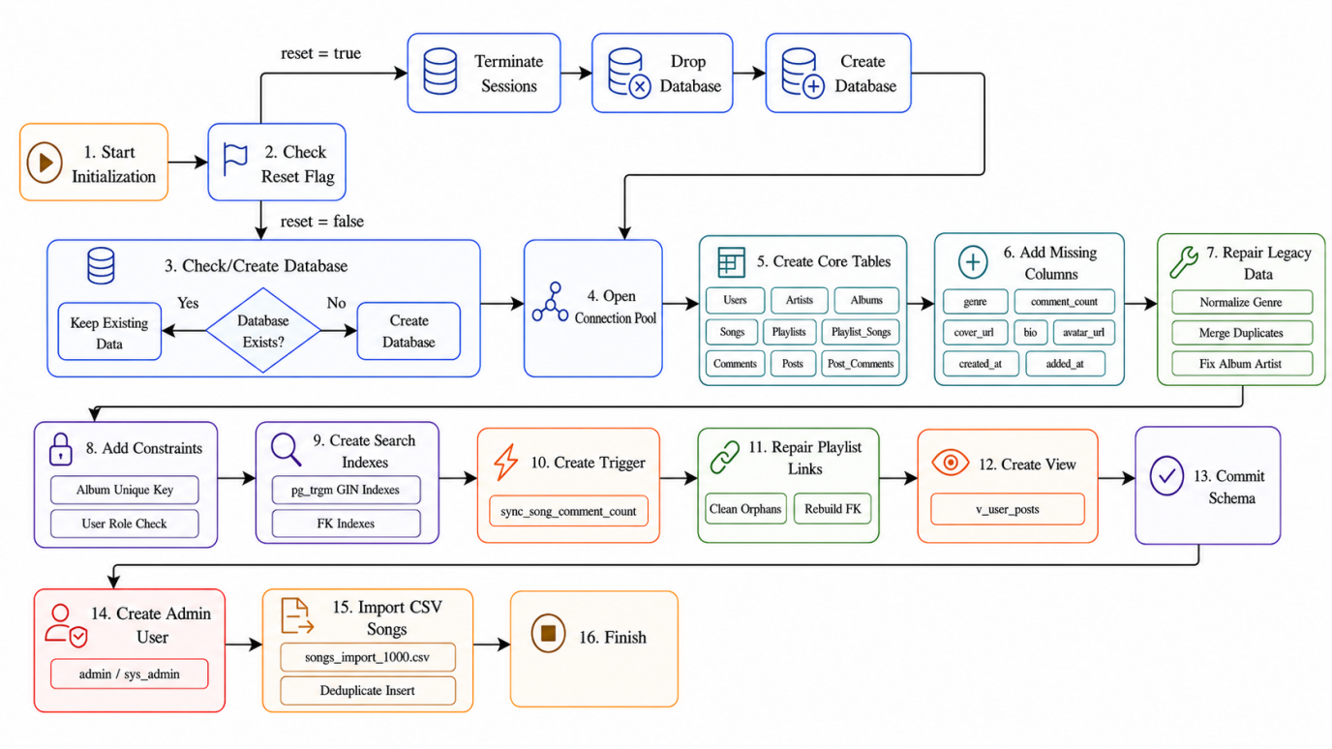
Figure 3 Database Initialization Flowchart
As shown in Figure 3, initialization begins with database checking or resetting, then proceeds to table creation, data repair, constraint and index construction, view and trigger creation, data import, and default administrator creation. The flowchart highlights dependency order: tables must exist before constraints and indexes can be added, and existing data must be cleaned before stricter rules are enforced.

User and Permission Module Implementation
The user and permission module is mainly implemented in auth.py. Its first responsibility is authentication. When a user account is created, the system does not store the original password. Instead, it uses Werkzeug to generate a PBKDF2-SHA256 password hash. During login, the system queries the user record by username and compares the input password with the stored hash. This design reduces the risk of password leakage.
After login succeeds, the system stores the current user’s user_id, username, and role in the session state. These values are then used by the permission control mechanism. Role-based access control is implemented through the auth.require_role(...) decorator. Before a protected function is executed, the decorator checks whether the current user has logged in and whether the user’s role is included in the allowed role list. If the role does not match the requirement, the operation is blocked before it reaches the business logic.
Figure 4 is used to show the permission workflow. Its main purpose is to explain how login verification and role checking work together to protect sensitive operations.
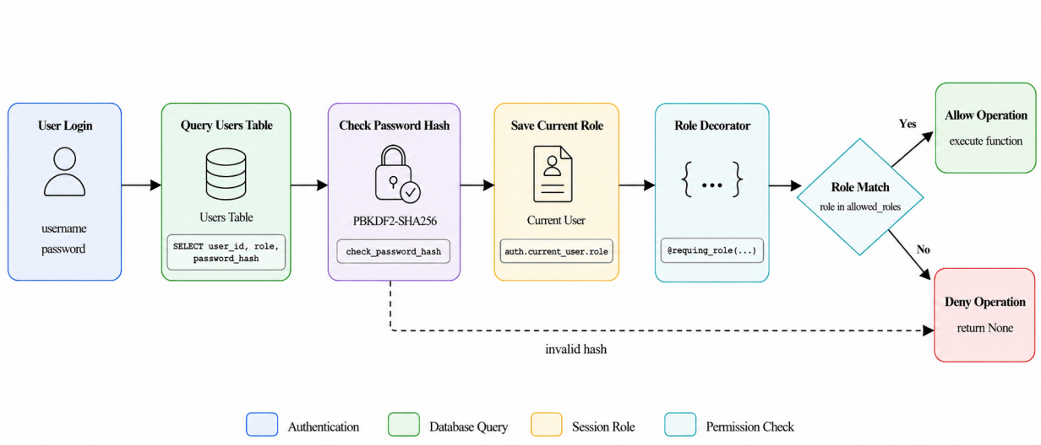
Figure 4 Permission Workflow Diagram
As shown in Figure 4, the workflow begins with user login. The system first queries the Users table and checks the password hash. If the password is correct, the user’s role is saved as part of the current session. When the user tries to perform an operation, the decorator checks the required role before allowing the function to run. If the role is valid, the operation continues; otherwise, access is denied. This process centralizes permission logic and prevents repeated role-checking code from being scattered across different business functions. It also makes the system easier to maintain because each protected function only needs to declare which roles are allowed.

Music Library Management Module Implementation
The music library management module is mainly implemented through music_service.py and music_manager.py. The service layer is responsible for input validation. It checks whether required fields such as song title, artist name, album information, and audio path are empty, and whether the song duration is valid. This prevents obviously incorrect data from entering the business logic layer.
After the input passes validation, the manager layer performs database operations. When a new song is added, the system first checks whether the corresponding artist already exists in the Artists table. If the artist does not exist, a new artist record is inserted and the generated artist_id is obtained. The same logic is then applied to the album. After both artist_id and album_id are available, the system inserts the song into the Songs table.
This order follows the foreign key dependency in the database. Since a song references an artist and may reference an album, the referenced records must exist before the song is inserted. If any step fails, the transaction is rolled back. This prevents incomplete operations, such as inserting an artist or album without successfully inserting the related song.
Figure 5 is used to describe the song addition process. Its main purpose is to show how input validation, database checking, conditional insertion, and transaction control work together during a typical write operation.
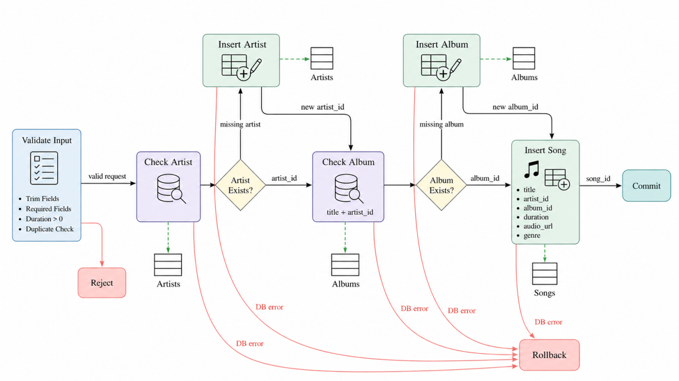
Figure 5 Song Addition Sequence Diagram
As shown in Figure 5, the process starts from the user submitting song information through the interface. The service layer first validates the input and rejects invalid data. If the input is valid, the manager layer checks the Artists table and Albums table in sequence. Missing artist or album records are created before the song is inserted. The final insertion happens in the Songs table, and the transaction is committed only after all required operations succeed. If an exception occurs, the system rolls back the transaction. This sequence ensures that the database remains consistent even when a write operation is interrupted.

Search Module Implementation
The search module is implemented as a cross-table fuzzy query. When a user enters a keyword, the system constructs a search pattern using %keyword%. It then joins Songs, Artists, and Albums so that the keyword can be matched against song titles, artist names, and album titles at the same time.
This implementation is more practical than exact matching because users may only remember part of a song name, an artist name, or an album title. The system does not require the user to specify which category the keyword belongs to. Instead, the database query searches across related tables and returns all relevant results.
The query results are ordered and paginated with LIMIT and OFFSET. Pagination prevents the frontend from loading too many records at once and improves interface responsiveness. After the database returns the result set, the frontend renders each song as a card that includes song information, audio playback, and interaction buttons. This design shows how database queries directly support user experience.

Playlist and Favorite Module Implementation
The playlist module is implemented through Playlists and Playlist_Songs. When a listener creates a playlist, the system inserts a playlist record with the current user as creator. When a song is added, the system inserts a relationship record into Playlist_Songs.
The composite primary key (playlist_id, song_id) prevents duplicate insertion of the same song into the same playlist. The favorite function reuses this structure by creating or locating a special playlist named “我喜欢的歌曲”. In implementation, the system first searches for this playlist under the current user and creates it only when it does not exist. This approach keeps the favorite function lightweight while remaining consistent with the existing playlist model.

Comment and Forum Module Implementation
The comment module inserts user comments into the Comments table. After a comment-related operation is completed, the database trigger updates the corresponding song’s comment_count, so the application does not need to maintain this value manually.
The forum module stores posts in Posts and replies in Post_Comments. When a post recommends a song, the song reference is stored as an optional foreign key. For forum display, the system reads from v_user_posts, which returns post, author, and recommended-song information in one result set. This implementation reduces repeated join logic in the frontend and keeps forum data retrieval stable.

Ranking Module Implementation
The ranking module is implemented through aggregate queries. The “most liked” ranking counts how many times each song appears in users’ favorite playlists. The query joins Songs, Playlist_Songs, and Playlists, groups records by song, and orders the result by favorite count.
The core logic can be represented as follows:
SELECT s.song_id, s.title, COUNT(*) AS like_count
FROM Songs s
JOIN Playlist_Songs ps ON s.song_id = ps.song_id
JOIN Playlists p ON ps.playlist_id = p.playlist_id
WHERE p.name = '我喜欢的歌曲'
GROUP BY s.song_id, s.title
ORDER BY like_count DESC;
The “most commented” ranking uses the maintained comment_count field in Songs. Since this field is synchronized by the database trigger, the system can display comment-based rankings without repeatedly calculating comment totals from the Comments table.

Frontend Interaction Design
The frontend is implemented with Streamlit and is connected to backend functions through the service and manager layers. After a user logs in, the interface reads the current user role and displays different pages according to permission level.
Listeners can access music discovery, playlists, comments, forum posts, and personal profile functions. Music administrators can manage music resources and forum content. System administrators can additionally manage user accounts. This frontend arrangement is consistent with the backend RBAC model. Users only see functions that match their roles, while sensitive operations are still protected by backend decorators.
The frontend does not directly manipulate the database. Instead, it sends user operations to the corresponding service or manager functions. This keeps the interface code simple and reduces the risk of bypassing validation or permission checks. As a result, the system maintains a clear implementation chain: the frontend handles interaction, the service layer checks input, the manager layer executes business logic, and the openGauss database enforces data rules.

Results Analysis

Functional Result Analysis
To verify the completeness of the system, functional testing was conducted on the main modules, including authentication, role-based access control, music management, fuzzy search, playlist operations, comments, forum interaction, ranking queries, deletion rules, triggers, and database initialization. Table 1 is used to summarize these test results because it directly shows whether each implemented module meets its expected behavior.
Test ID | Module | Test Operation | Expected Result | Actual Result | Status
FT-01 | Authentication & RBAC | Register, log in, and access functions with different roles | Passwords are hashed, login is verified, and unauthorized operations are blocked | Authentication and role-based access control worked correctly | Passed
FT-02 | Music Management | Add, update, delete, and query songs with artist and album information | Music records are correctly maintained with valid foreign key relations | CRUD operations on songs, artists, and albums worked as expected | Passed
FT-03 | Database Constraints | Insert duplicate songs or invalid duration values | Invalid data is rejected by UNIQUE and CHECK constraints | Duplicate and invalid records were successfully blocked | Passed
FT-04 | Search Module | Search by song title, artist name, or album title | Matched records are returned through fuzzy search and joined queries | Search results were accurate and relevant | Passed
FT-05 | Playlist & Favorites | Create playlists, add songs, and add songs to “我喜欢的歌曲” | Playlist-song relations are correctly stored without duplication | Playlist and favorite operations worked normally | Passed
FT-06 | Comments & Trigger | Add, delete, or modify song comments | Songs.comment_count remains consistent with Comments | The trigger maintained comment counts automatically | Passed
FT-07 | Forum Module | Create posts, recommend songs, and add post comments | Posts and comments are stored correctly; optional song references support SET_NULL | Community functions worked correctly | Passed
FT-08 | Ranking Module | Query most liked and most commented songs | Songs are ranked according to favorite playlist statistics and comment counts | Ranking results were generated correctly | Passed
FT-09 | Deletion Rules | Delete playlists, songs, users, or referenced songs | Strong dependent data is cascaded; optional references are set to NULL | ON DELETE CASCADE and ON DELETE SET NULL behaved as designed | Passed
FT-10 | Database Initialization | Run db_init.py to initialize database objects and import data | Tables, constraints, indexes, views, triggers, initial data, and default admin are created | Initialization completed successfully | Passed
The results in Table 1 show that the system satisfies the main requirements of the course project. Basic user operations, administrative functions, fuzzy search, permission control, and database initialization all passed functional testing. More importantly, the tests confirm that key database mechanisms, including constraints, triggers, transaction rollback, and deletion rules, worked together with the application layer rather than remaining only as design assumptions.

Database Result Analysis
The database results confirm that user operations were correctly reflected in the underlying data. Playlist management, song commenting, post creation, deletion behavior, and derived comment statistics all matched the expected database rules.
Figure 6 is used to show representative user-side playlist and comment operations. It is included because these operations verify whether frontend behavior is correctly synchronized with database records.
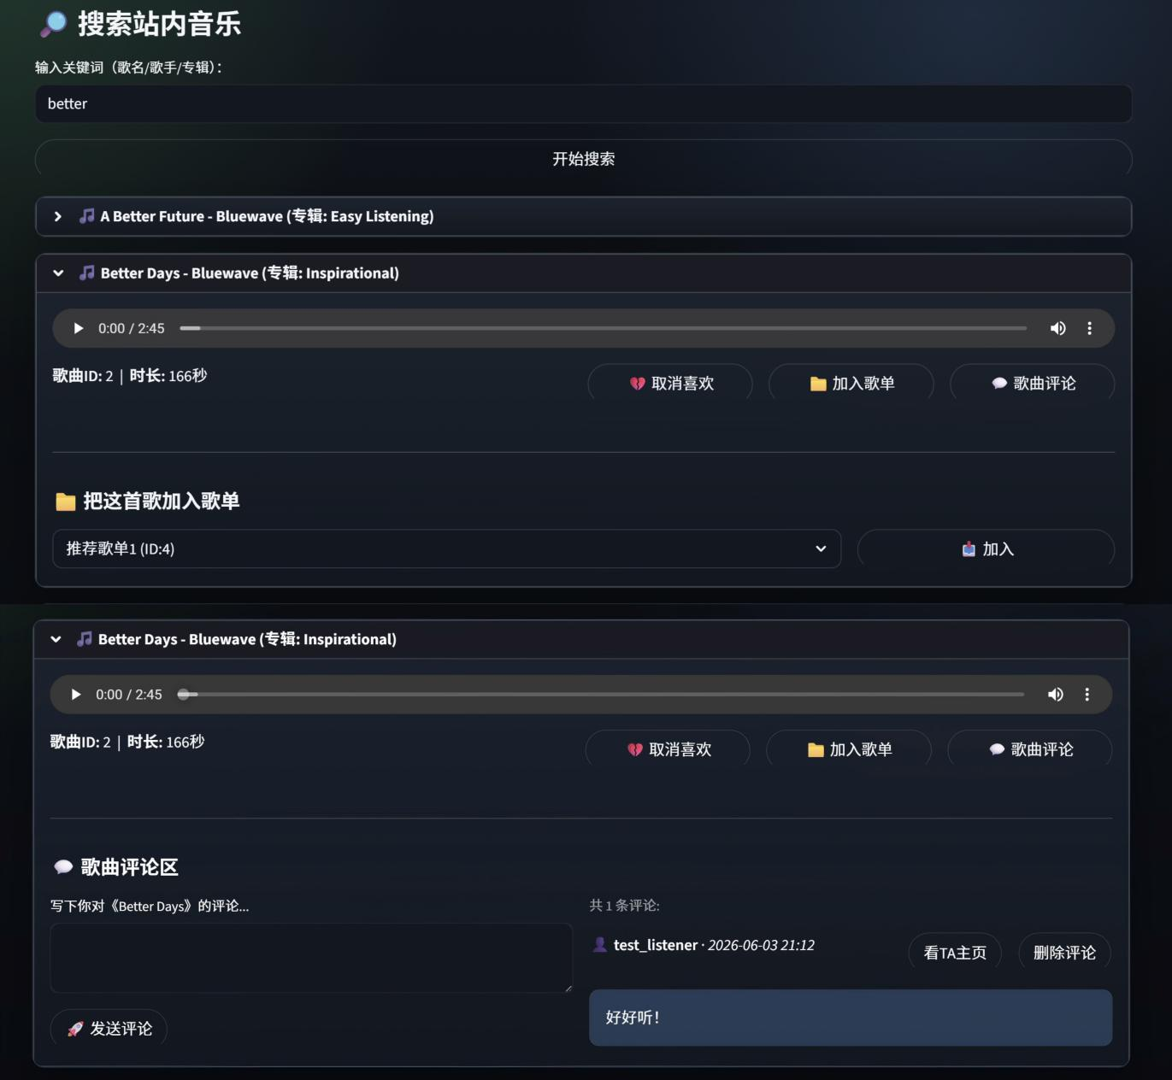
Figure 6 User-side Playlist and Comment Features
Figure 6 shows that playlist and comment operations can be completed through the user interface and stored correctly in the database. The test results also confirm that duplicate playlist-song records are prevented, comment counts are updated automatically, and deletion rules behave as expected. Therefore, the database model supports actual user workflows rather than only static table storage.

Query Result Analysis
The query results show that the system provides practical retrieval and ranking functions. Fuzzy search allows users to search by song title, artist name, or album title without specifying the exact field.
Figure 7 is used to show the fuzzy search result. It is included because search is one of the most important user-facing database functions and directly reflects whether joined queries improve usability.
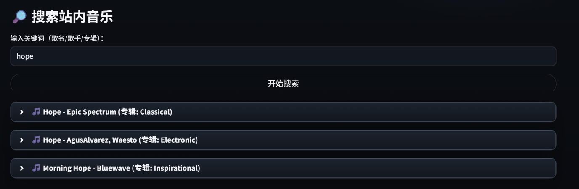
Figure 7 Fuzzy Search Result
Figure 7 shows that partial or category-independent keywords can return relevant song records. The returned results include related song metadata and interaction options, which confirms that cross-table query results are correctly displayed on the frontend.
The ranking function further verifies the use of aggregate queries. The “most liked” ranking is based on favorite records, while the “most commented” ranking uses maintained comment statistics. These results show that the system can support both record retrieval and simple statistical analysis of user behavior.

Security and Permission Result Analysis
The security and permission results focus on whether different roles can access only their assigned functions. The system displays different interfaces according to the current role, while sensitive backend functions are protected by decorators.
Figures 8 to 10 are used to compare the interfaces of the system administrator, music administrator, and listener. They are included to verify whether the frontend display is consistent with the backend permission model.
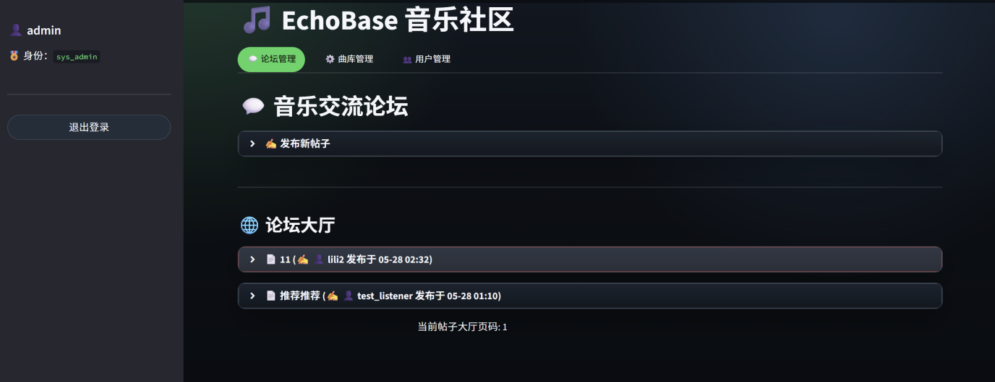
Figure 8 Admin Login Interface
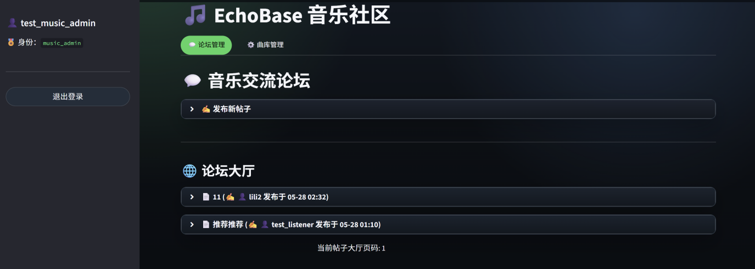
Figure 9 Music_admin Login Interface
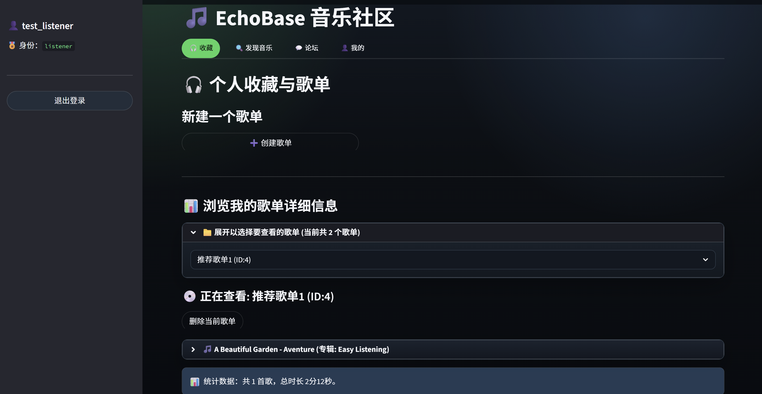
Figure 10 Listener Login Interface
As shown in Figures 8 to 10, the system administrator has access to user and system management functions, the music administrator can manage music and community content, and the listener can use ordinary interaction functions such as search, playlist, comments, and forum participation. This comparison confirms that permission boundaries are correctly reflected in the interface. In addition, password hashing and parameterized SQL queries verify that security is considered in both authentication and database access.

Operation Result Analysis
The operation results further show that database functions are connected to actual interface behavior. Song addition and forum use are selected as representative examples because they involve frontend input, backend validation, database writing, and constraint checking.
Figure 11 is used to show the song addition function. It is included because adding a song is a typical write operation that tests input validation, dependency handling, duplicate prevention, and transaction control.
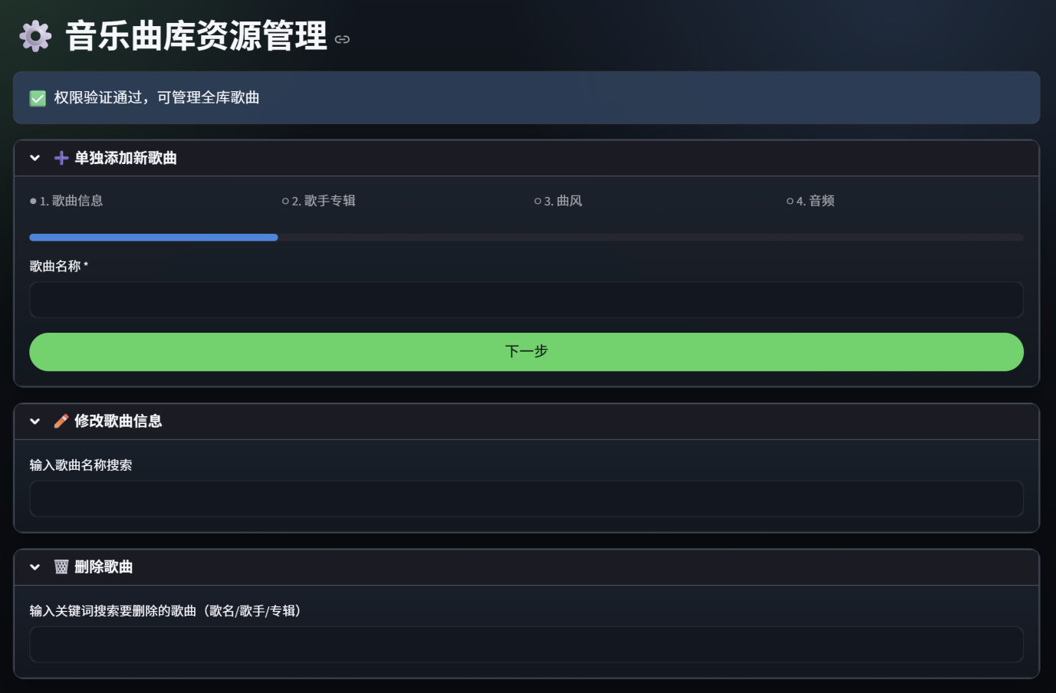
Figure 11 Add Songs
Figure 11 shows that song information can be submitted through the interface and processed by the backend. The result confirms that the system can validate input, handle related artist and album records, and prevent duplicate song insertion through database constraints.
Figure 12 is used to show the forum function. It is included because the forum module verifies user-generated content, optional song recommendation, post replies, and multi-table display.

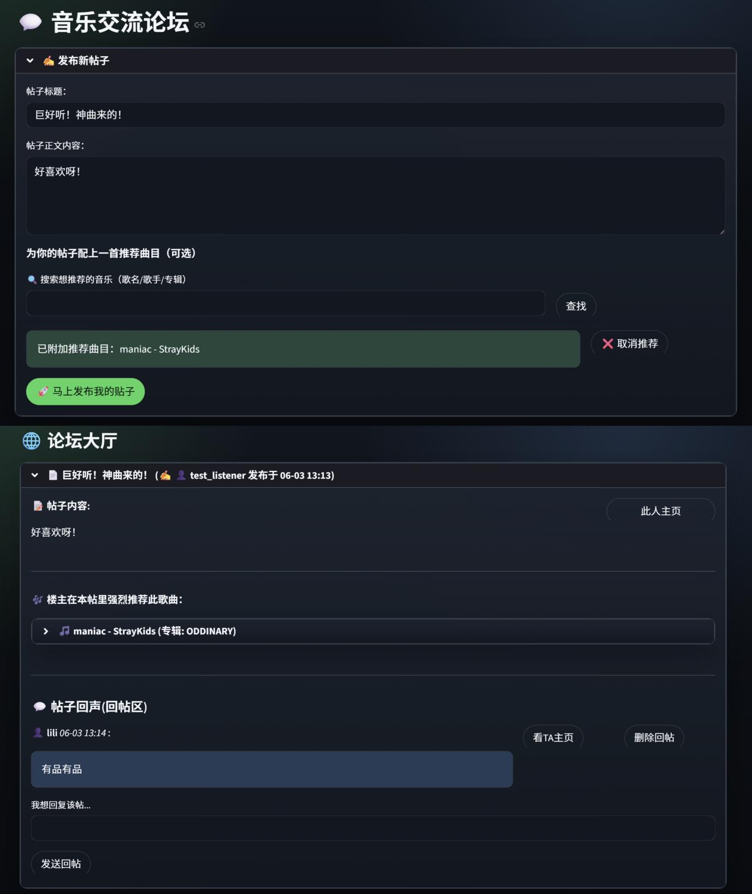
Figure 12 Forum Feature
Figure 12 shows that users can publish posts, recommend songs, and participate in discussions. The result confirms that community interaction is correctly connected with user and music data, and that the forum interface can display integrated information without exposing database complexity to users.

Course Design Summary

What We Learned
The most important lesson from this project is that database design decisions directly affect application reliability. At first, it was easy to focus only on whether each function could run. During implementation, however, we realized that a function is not truly reliable unless the underlying schema can prevent invalid data, preserve correct relationships, and support future changes.
We also gained a more practical understanding of normalization and controlled redundancy. Normalization helped reduce repeated information and avoid common data anomalies, while the comment_count field showed that limited redundancy can be useful when it is maintained by a reliable mechanism. This experience helped us understand that database design is not a fixed formula, but a balance between clarity, consistency, and efficiency.

Problems Encountered and Solutions
Several problems during development came from the need to align database rules with real business meaning. One example was duplicate prevention. In a music system, different artists may have albums or songs with the same name, so a single title field cannot be used as a unique constraint. We therefore used composite unique constraints such as (title, artist_id) for albums and (title, artist_id, album_id) for songs. This solution prevents true duplicates without rejecting valid records.
Another challenge was reducing repeated application logic. Forum display originally required long join queries, and comment statistics could have required repeated aggregate queries or manual updates. To solve these problems, we used v_user_posts to simplify forum retrieval and used a trigger to maintain Songs.comment_count. These solutions made us realize that some problems are more reliable when handled by the database rather than scattered across application functions.
The favorite function also revealed the trade-off between implementation simplicity and model strictness. Reusing a special playlist kept the system lightweight, but it also made favorite ranking depend on the correctness of that playlist. A future design with an is_favorite field or a separate Favorites table would make this relationship clearer. Similarly, deletion rules taught us that technical convenience should not be the only criterion. Strongly dependent records can be deleted by cascade, while forum posts should be preserved when only their recommended song is removed.

Debugging and Implementation Reflections
During implementation, debugging was not limited to fixing syntax errors. Many problems came from the interaction between application logic and database rules. For example, a function might work correctly on the interface, but fail when the database constraint rejected an invalid or duplicate record. This forced us to check not only Python code, but also SQL statements, table definitions, transaction behavior, and existing data.
The initialization script also improved our understanding of system robustness. Since the database may be initialized more than once during development, the script cannot simply create objects blindly. It needs to check whether columns, constraints, indexes, views, and triggers already exist. It also needs to repair historical data before applying stricter rules. This process taught us that a reliable system should consider repeated execution, incomplete states, and rollback behavior.
We also became more careful about layered design. Input validation should happen before database operations, permission checks should happen before protected functions are executed, and transaction commits should happen only after all related operations succeed. When these responsibilities are mixed together, the code becomes difficult to debug. After separating the presentation layer, service layer, business logic layer, and database layer, each problem became easier to locate.

Future Improvements
Although the system has implemented the main requirements, it can still be improved in three directions. First, the favorite model can be made more rigorous by introducing an is_favorite field or a separate Favorites table. Second, administrator operation audit logs can be added to record who changed which data and when, making system management more traceable. Third, future testing can include more quantitative evidence, such as query time comparisons with and without indexes, larger-scale data imports, and basic stress testing.
The system can also be extended with play history, song tags, user following, and personalized recommendation. These functions can be built on the current relational model without completely redesigning the database, which shows that the present schema has reasonable extensibility.
Overall, this project helped us move beyond simply writing SQL statements. We learned how constraints, views, triggers, indexes, transactions, and layered implementation work together to support a reliable database application. Through this process, we developed not only a working system, but also a clearer understanding of how database design affects security, maintainability, and real user workflows.

Team Member Responsibilities

Member | Main Responsibility | Core Contribution Summary
Li Xiaotong | Frontend-backend interaction & report writing | Integrated frontend and backend workflows; implemented login, registration, search, music and playlist management, comments, forum functions, and user management; authored and refined the English project report.
Mo Zebang | Project structure & database/backend foundation | Built overall project framework with Python, Streamlit, and openGauss; implemented database connection, initialization, core tables, constraints, indexes, view, and trigger; supported backend operations for users, songs, playlists, comments, and forum modules.
Yang Runyu | Frontend-backend interaction & integration testing | Connected UI operations to backend logic; tested and integrated music management, playlists, forum interactions, permissions, and ranking; identified and resolved issues in interaction logic and data presentation.
Sheng Yiwen | Testing | Test system functionality

